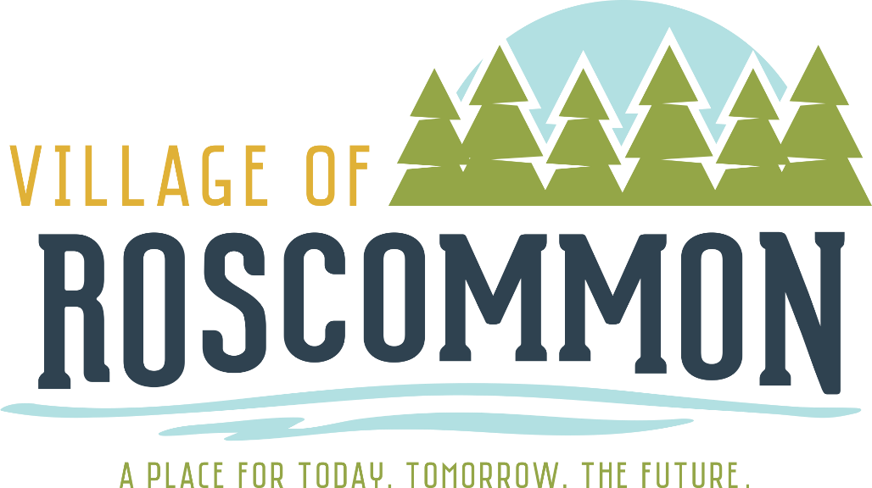

Downtown Development Authority

Project List

2021-2022

September 14, 2021
Completed Projects (Past Several Years)
- Public Library contribution
- New Dock & Stairway at Wallace Park
- Lake Street Building Demolition
- Roscommon County Courts Facility Funding
- Downtown Railroad parking Project
- New Roads in Industrial Park
- Village Sidewalks
- Downtown Beautification
- Sidewalk Pavers and Lighting
- Light Pole Banners
- Downtown Clock
- Downtown Snow Removal
- Purchase, improvements, resale, and redevelopment of AuSable Drug Building
- Walkway from Village to Hilltop Apartments
Future Projects:
- Hiawatha Canoe Livery
- Metro Park Improvements
- Village Flowers
- New Street Banners
- Farmers’ Market Support

